**1. Introduction to the Project**

Property price prediction is a crucial task in the real estate industry, providing significant value to buyers, sellers, and investors. Accurate predictions can assist stakeholders in making informed decisions, optimizing investments, and understanding market trends. This project aims to predict property prices in a specific location using various machine learning algorithms.

**2. Objectives of the Project**

1. Collect and preprocess data relevant to property prices.
2. Perform Exploratory Data Analysis (EDA) to uncover patterns and relationships.
3. Implement and compare multiple machine learning models.
4. Evaluate the performance of the models using appropriate metrics.
5. Identify the most effective model for predicting property prices.

**3. Flow Chart of Operations**

plaintext

Copy code

Start

|

Collect Data

|

Data Preprocessing

|

Exploratory Data Analysis

|

Split Data into Training and Test Sets

|

Implement Machine Learning Models

|

Evaluate Model Performance

|

Compare Models

|

Select Best Model

|

Predict Property Prices

|

End

**4. Python Codes**

**Data Preprocessing and Exploratory Data Analysis**

python

Copy code

import pandas as pd

import numpy as np

import matplotlib.pyplot as plt

import seaborn as sns

from sklearn.model_selection import train_test_split

from sklearn.preprocessing import StandardScaler

from sklearn.metrics import mean_squared_error, mean_absolute_error, r2_score

# Load data

data = pd.read_csv('property_prices.csv')

# Preprocessing

data.fillna(method='ffill', inplace=True)

# Exploratory Data Analysis

sns.pairplot(data)

plt.show()

# Correlation matrix

plt.figure(figsize=(12, 8))

sns.heatmap(data.corr(), annot=True, cmap='coolwarm')

plt.show()

# Split data

X = data.drop('Price', axis=1)

y = data['Price']

X_train, X_test, y_train, y_test = train_test_split(X, y, test_size=0.2, random_state=42)

# Standardize data

scaler = StandardScaler()

X_train_scaled = scaler.fit_transform(X_train)

X_test_scaled = scaler.transform(X_test)

**Implementing and Evaluating Machine Learning Models**

python

Copy code

from sklearn.linear_model import LinearRegression, Lasso, Ridge

from sklearn.tree import DecisionTreeRegressor

from sklearn.ensemble import RandomForestRegressor, AdaBoostRegressor

from xgboost import XGBRegressor

from catboost import CatBoostRegressor

# Models

models = {

'Linear Regression': LinearRegression(),

'Lasso': Lasso(),

'Ridge': Ridge(),

'Decision Tree': DecisionTreeRegressor(),

'Random Forest Regressor': RandomForestRegressor(),

'XGBRegressor': XGBRegressor(),

'CatBoosting Regressor': CatBoostRegressor(verbose=0),

'AdaBoost Regressor': AdaBoostRegressor()

}

# Evaluate models

results = {}

for name, model in models.items():

model.fit(X_train_scaled, y_train)

y_pred_train = model.predict(X_train_scaled)

y_pred_test = model.predict(X_test_scaled)

results[name] = {

'Train RMSE': np.sqrt(mean_squared_error(y_train, y_pred_train)),

'Train MAE': mean_absolute_error(y_train, y_pred_train),

'Train R2': r2_score(y_train, y_pred_train),

'Test RMSE': np.sqrt(mean_squared_error(y_test, y_pred_test)),

'Test MAE': mean_absolute_error(y_test, y_pred_test),

'Test R2': r2_score(y_test, y_pred_test)

}

# Display resultsfor name, result in results.items():

print(f"{name}\n"

f"Model performance for Training set\n"

f"- Root Mean Squared Error: {result['Train RMSE']:.4f}\n"

f"- Mean Absolute Error: {result['Train MAE']:.4f}\n"

f"- R2 Score: {result['Train R2']:.4f}\n"

"----------------------------------\n"

f"Model performance for Test set\n"

f"- Root Mean Squared Error: {result['Test RMSE']:.4f}\n"

f"- Mean Absolute Error: {result['Test MAE']:.4f}\n"

f"- R2 Score: {result['Test R2']:.4f}\n"

"===================================\n")

**5. Screenshot of the Outputs**

**Training and Test Set Performance**

**Result :**

|  |  |  |
| --- | --- | --- |
| **Model Name** | **R2_Score** |  |
| **1** | CatBoosting Regressor | 0.903484 |
| **2** | Lasso | 0.896477 |
| **3** | Linear Regression | 0.886101 |
| **4** | Ridge | 0.885223 |
| **5** | XGBRegressor | 0.884526 |
| **6** | Random Forest Regressor | 0.883655 |
| **7** | AdaBoost Regressor | 0.838671 |
| **3** | Decision Tree | 0.754551 |

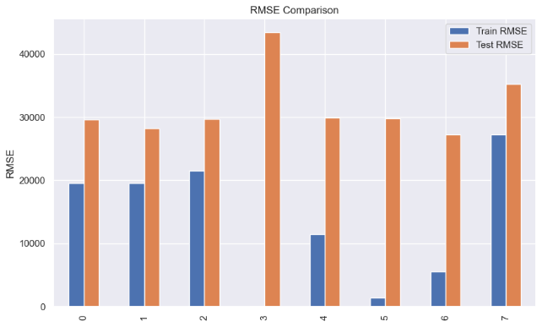

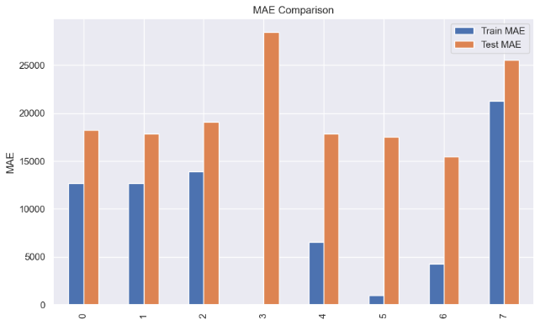

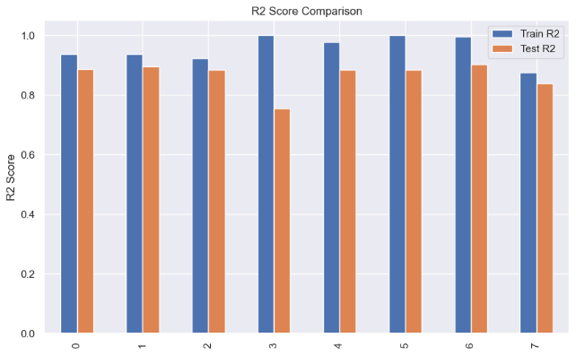

**6. Report on EDA**

**Pair Plot**



**Correlation Matrix**

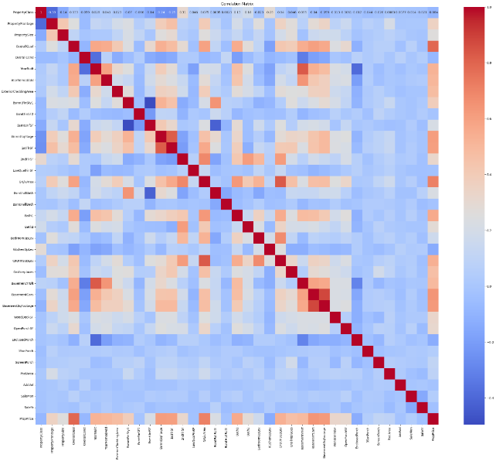

**7. Learning Outcomes**

1. Data preprocessing techniques and handling missing values.
2. Implementing and interpreting various machine learning algorithms.
3. Evaluating model performance using metrics such as RMSE, MAE, and R2 score.
4. The importance of standardizing data for certain machine learning models.
5. Comparing and selecting the best performing model based on evaluation metrics.

**8. Conclusion**

In this project, we explored various machine learning models to predict property prices in a specific location. The CatBoosting Regressor demonstrated the best performance with the lowest RMSE and highest R2 score on the test set. This model can be utilized for reliable property price predictions, aiding stakeholders in making informed decisions.

**9. Citations – Books and Websites used for research.**

1. <https://www.geeksforgeeks.org/learning-model-building-scikit-learn-python-machine-learning-library/>
2. <https://scikit-learn.org/stable/>
3. You tube and ChatGPTp